**Assignment 3**

**Name:Tian Zhou**

**NETID:tz164**

**Q1.**

The program of Q1 is in the Q1&2 file.

“leanLeft()” function is used to lean the 2-3 tree to the left.

”leanRight()” function is used to lean the 2-3 tree to the left.

“insert()”function is used to insert a node to the tree.

“print()”function is used to print the tree in order. (ascending)

**Q2.**

This question also use the program in the Q1&2 file.

Run the program by inserting 101, 102, 103, 104, 105 random Nodes to the tree. Each value of N was tested 5 times the get the result of average path length:

Table 3-2-1

|  |  |  |  |  |  |
| --- | --- | --- | --- | --- | --- |
| N | | 100 | 1000 | 10000 | 100000 |
| logN | | 2 | 3 | 4 | 5 |
| result of experiment  (Path Length) | 1 | 367 | 5975 | 93424 | 1212913 |
| 2 | 417 | 6144 | 93696 | 1190652 |
| 3 | 385 | 5995 | 89958 | 1218106 |
| 4 | 329 | 6322 | 90786 | 1201477 |
| 5 | 355 | 6648 | 93079 | 1171750 |
| average of result | | 371 | 6217 | 92189 | 1198980 |
| average for each node | | 3.71 | 6.22 | 9.22 | 11.99 |
| 3*N*(logN-1) | | 300 | 6000 | 90000 | 1200000 |
| 3*(logN-1) | | 3 | 6 | 9 | 12 |

As we can see in the table, the estimating value of average path length is **3*(log10N-1)** or **O(lgN)** .

For N-random insertions (assume N is large), the estimation of average path length is **3*(log10N-1) .**

(ii)

1. sorted insertions.

N=20,200,2000,20000

Table 3-2-2

|  |  |  |  |  |
| --- | --- | --- | --- | --- |
| N | 20 | 200 | 2000 | 20000 |
| 2*10^1 | 2*10^2 | 2*10^3 | 2*10^4 |
| log(N/2) | 1 | 2 | 3 | 4 |
| result(Path Length) | 90 | 9900 | 999000 | 99990000 |
| 10^2-10^1 | 10^4-10^2 | 10^6-10^3 | 10^8-10^4 |
| Path Length=N/2*(N/2-1)  Average Path Length=1/2*(N/2-1) | | | | |

Since the program will hook the new node onto the bottom with a black link when inserting into a 3-node at the bottom, the N-sorted insertions could have a large value of average path length.

As we can see in the table, the estimating value of average path length is **1/2*(N/2-1)** or **O(N)** .

**Q3.**

**Compute given red-black tree.**

The percentage of red nodes in a given red-black tree is 0.013508.

The size of given data is 1000000.

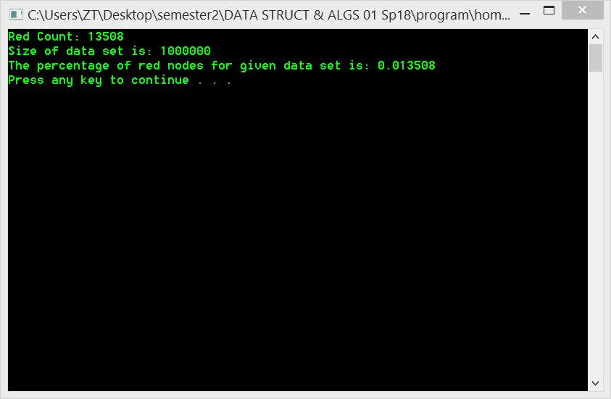

**100 trials for each size of data: N=104,** **105, 2*105, 106.**

The average of 100 trials result is:

Table 3-3-1

|  |  |  |  |
| --- | --- | --- | --- |
| 10000 | | 100000 | |
| count | percentage | count | percentage |
| 4864.87 | 0.486487 | 46927.09 | 0.4692709 |
| 200000 | | 1000000 | |
| count | percentage | count | percentage |
| 83482.66 | 0.4174133 | 188933.13 | 0.18893313 |

As we can see in the table, when the size of data grows up, the percentage of red nodes descends.

**Q4.**

Table 3-4-1

|  |  |  |  |  |  |
| --- | --- | --- | --- | --- | --- |
| **10** | | | **100** | | |
| std deviation | | 0.145804664 | std deviation | | 0.08600387 |
| total | average | variance | total | average | variance |
| 21.99 | 2.199 | 0.021259 | 541.312 | 5.41312 | 0.007396666 |
| **1000** | | | **10000** | | |
| std deviation | | 0.040609382 | std deviation | | 0.030961996 |
| total | average | variance | total | average | variance |
| 8774.01 | 8.77401 | 0.001649122 | 121647.418 | 12.1647418 | 0.000958645 |

Each size of data has 1000 trials to compute the average length of a path for a random node.The result of average and standard deviation for each size is show in the Table 3-4.

(More specific data of trials is in the “homework3.xlsx” file. )

Depends on the average value, we can assume the average length of a path for size N is approximately :****

Table 3-4-2

|  |  |  |
| --- | --- | --- |
| Size | Average | lgN-1 |
| 10 | 2.199 | 2.322 |
| 100 | 5.413 | 5.644 |
| 1000 | 8.774 | 8.966 |
| 10000 | 12.165 | 12.288 |

For the standard deviation: It’s obvious that when the size of data is more larger ,the value of standard deviation is more smaller, which means the result of random samples insertion become more stable.

**Q5.**

The program use the data set in “select-data.txt” file. (already include in the Q5 file)

The implementation of rank() and select() ordered operation for a BST is in the program 3_5 in Q5 file. Total size of data size is 1000000 (106).

1. The value of select(7) for the data set is 1.
2. The value of rank(7) for the data set is 6105.

Both rank() and select() functions use recursive to find the key or the rank. Once find the request node, the function will not run right part.